[**observable_monolith**](https://github.com/yogurt98/observable_monolith)

Set WordPress, Prometheus and Grafana

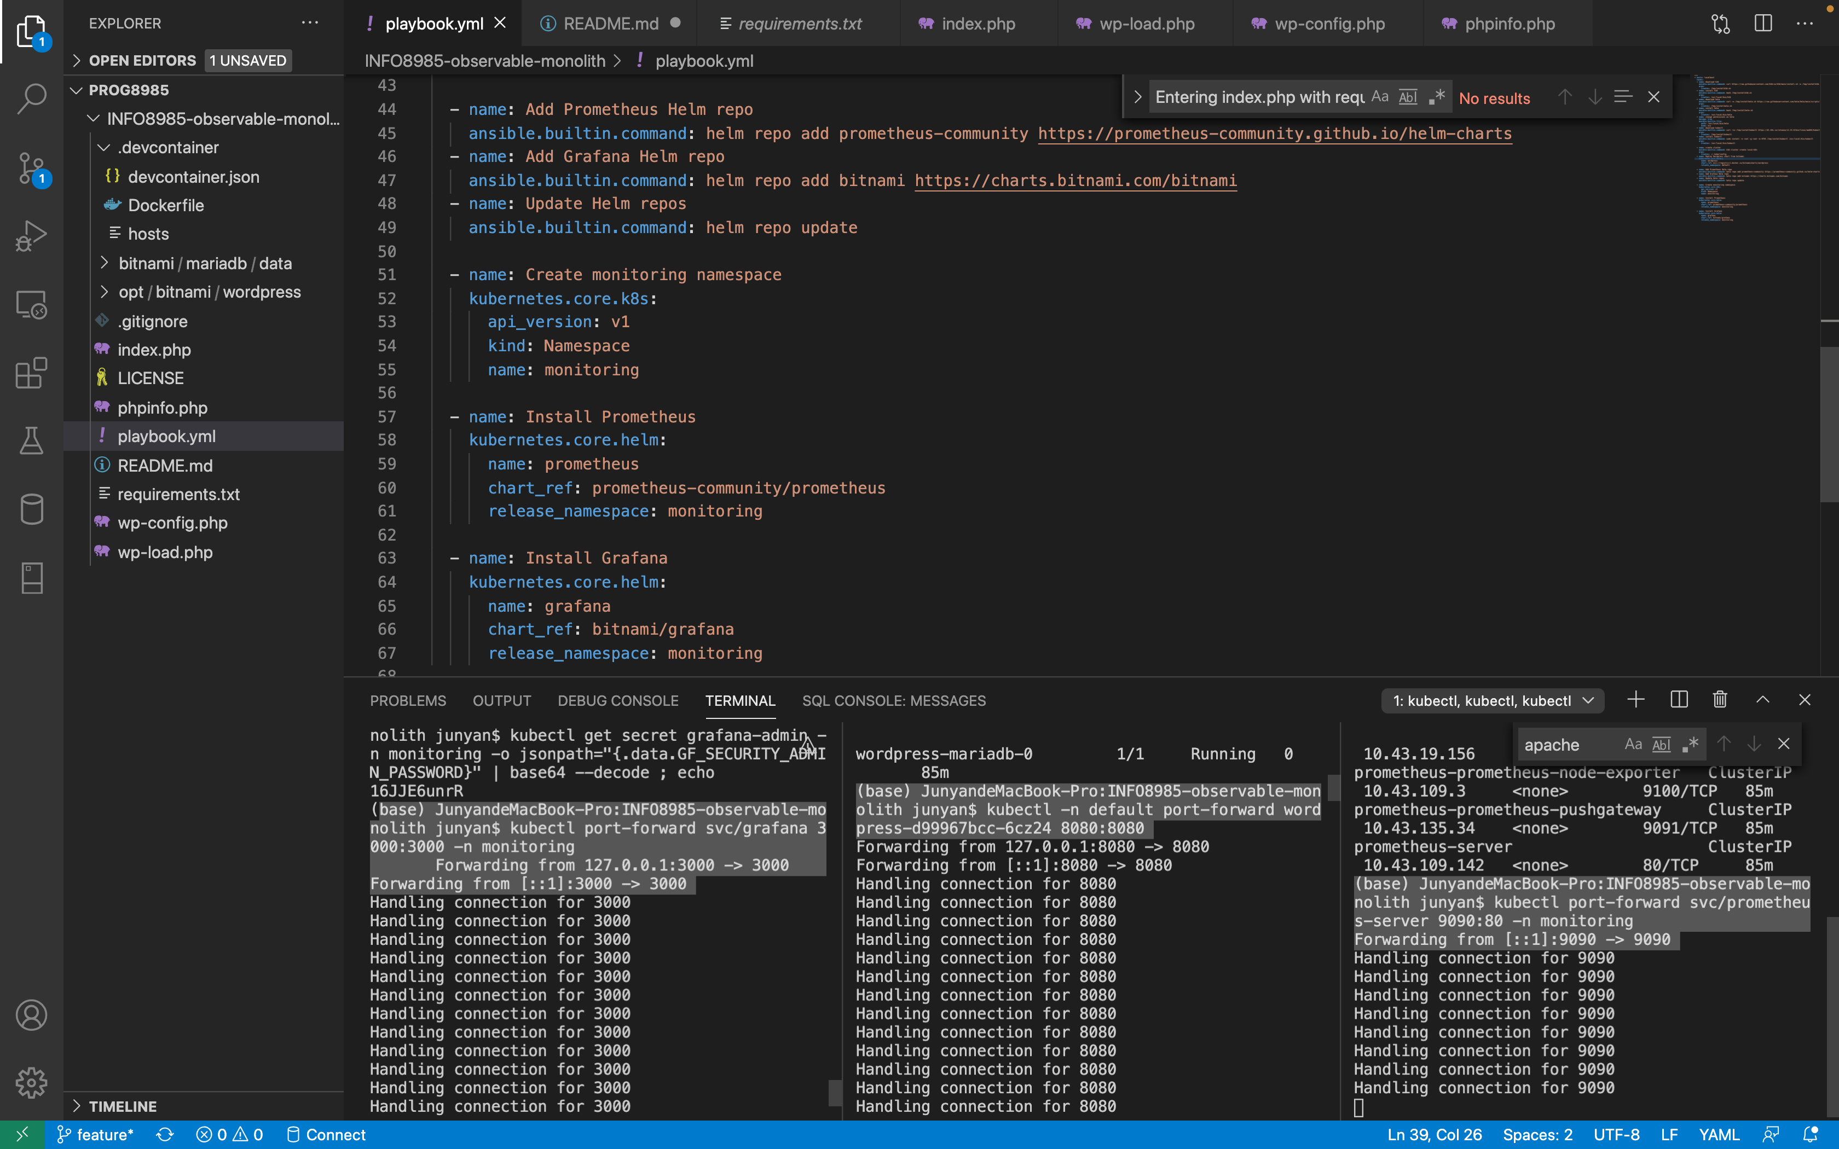

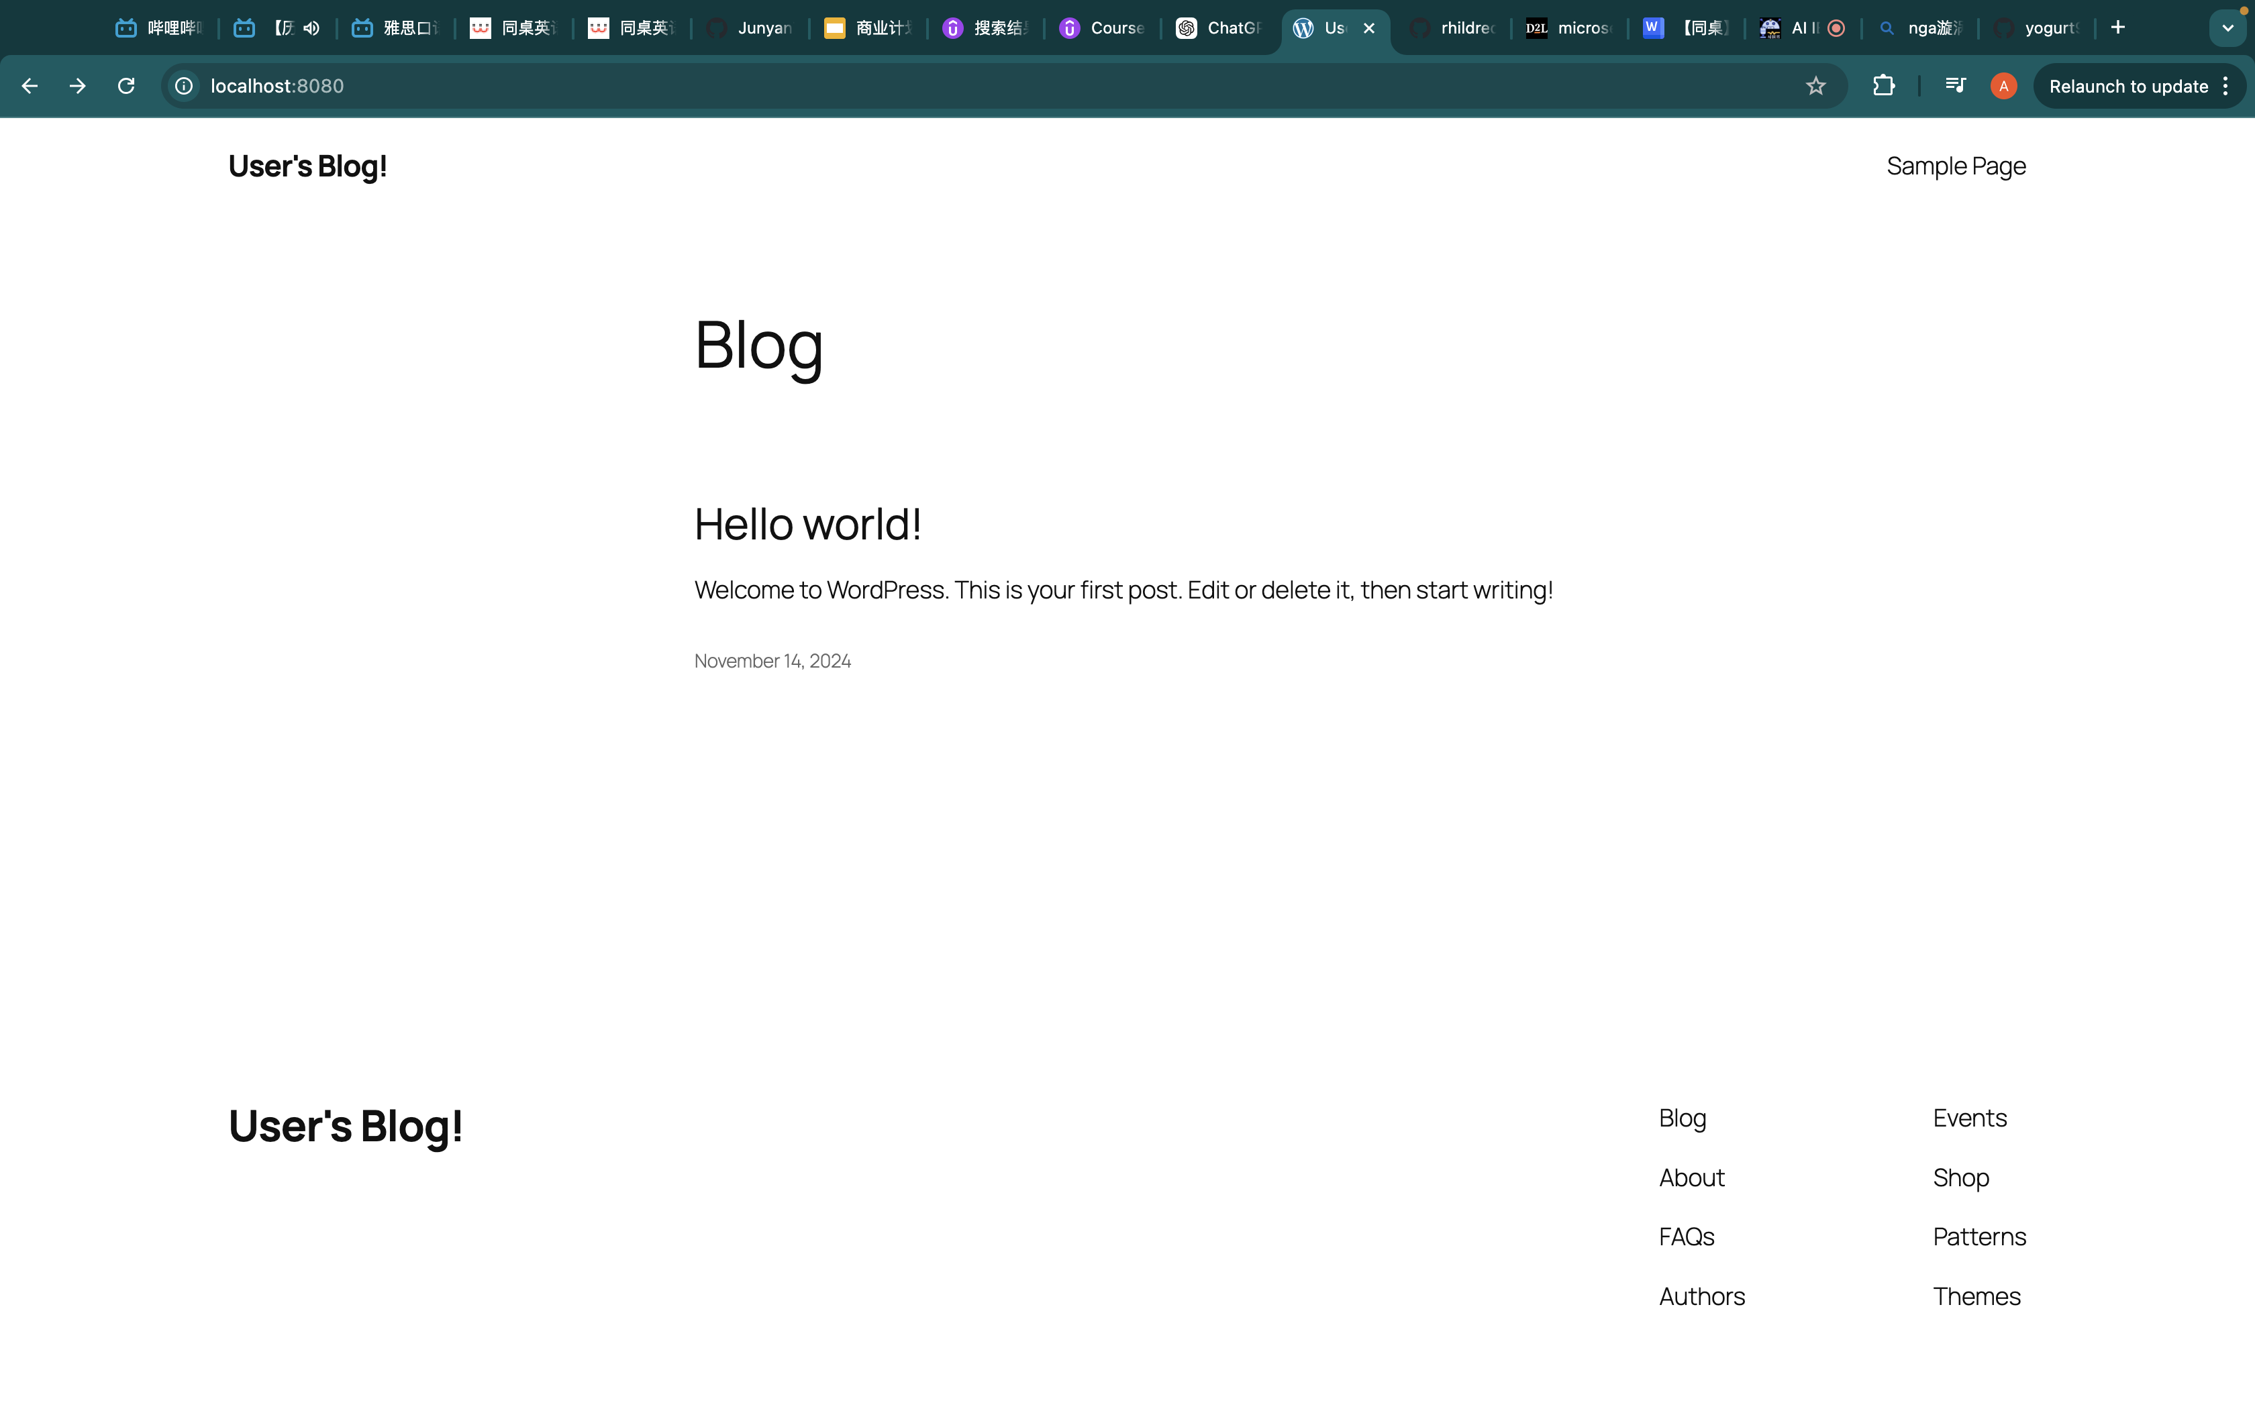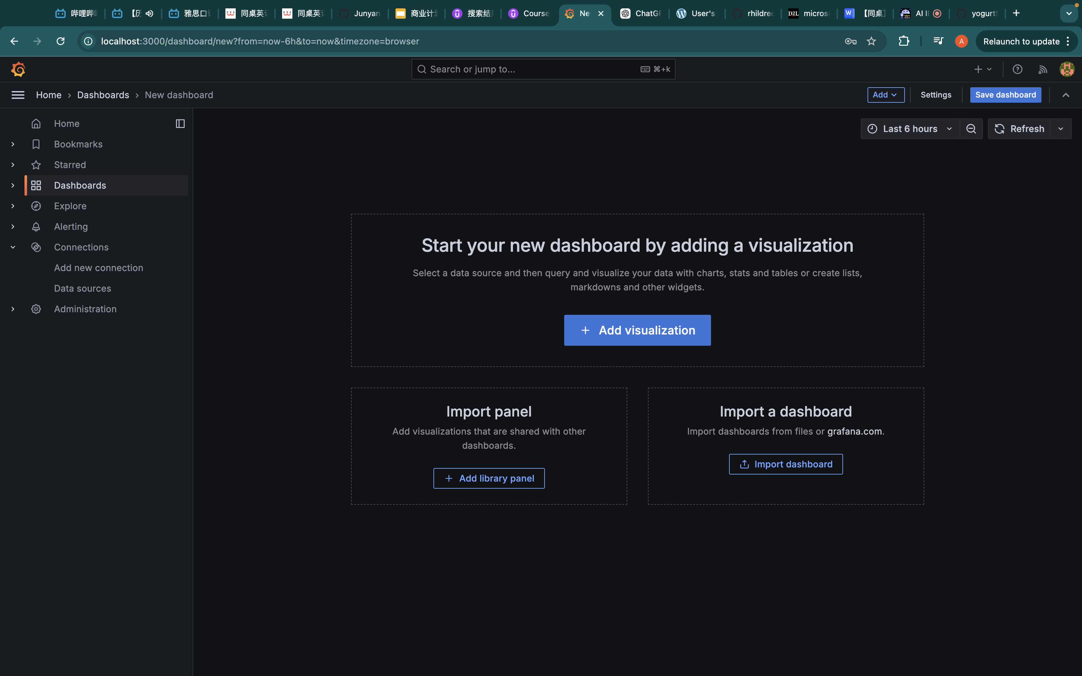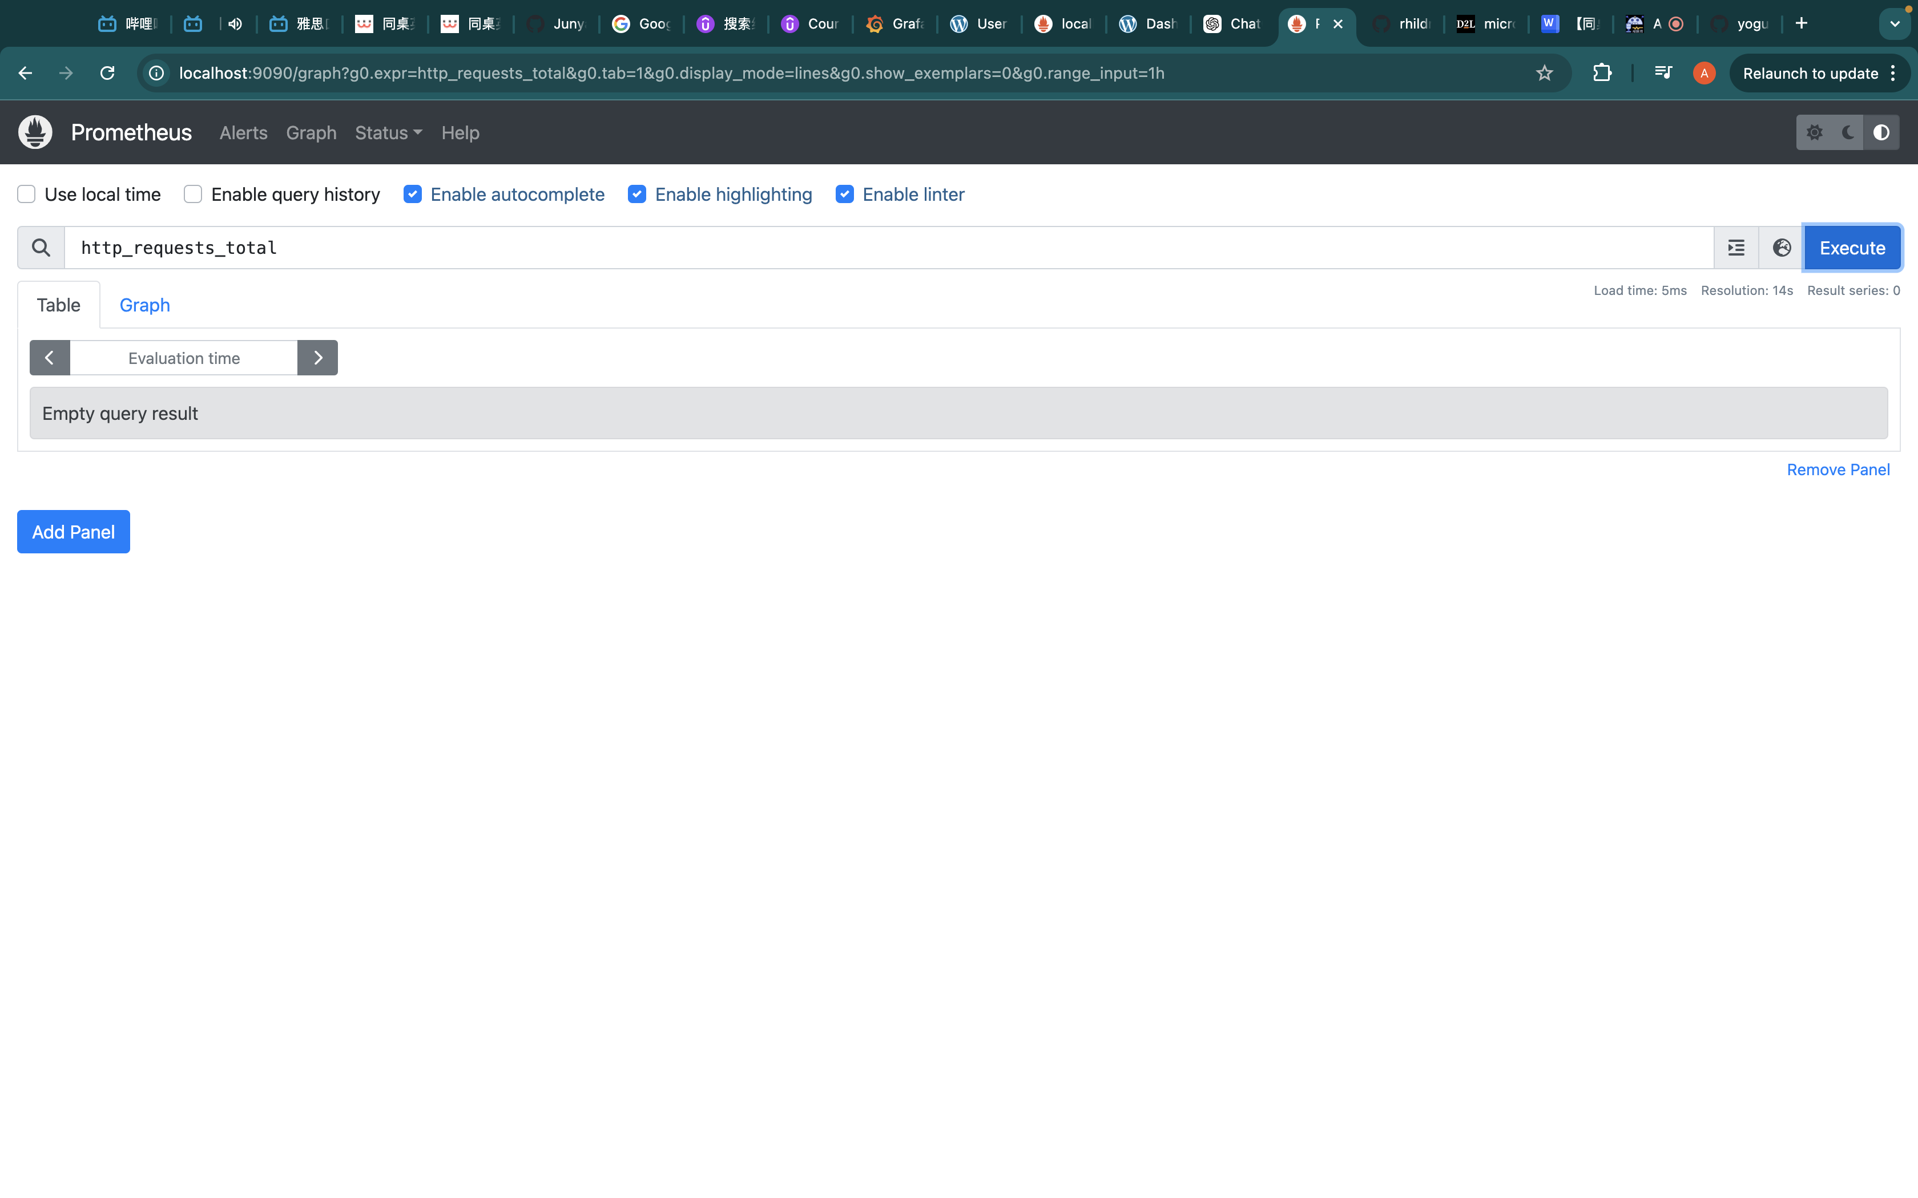

**Capture REDS Metrics**

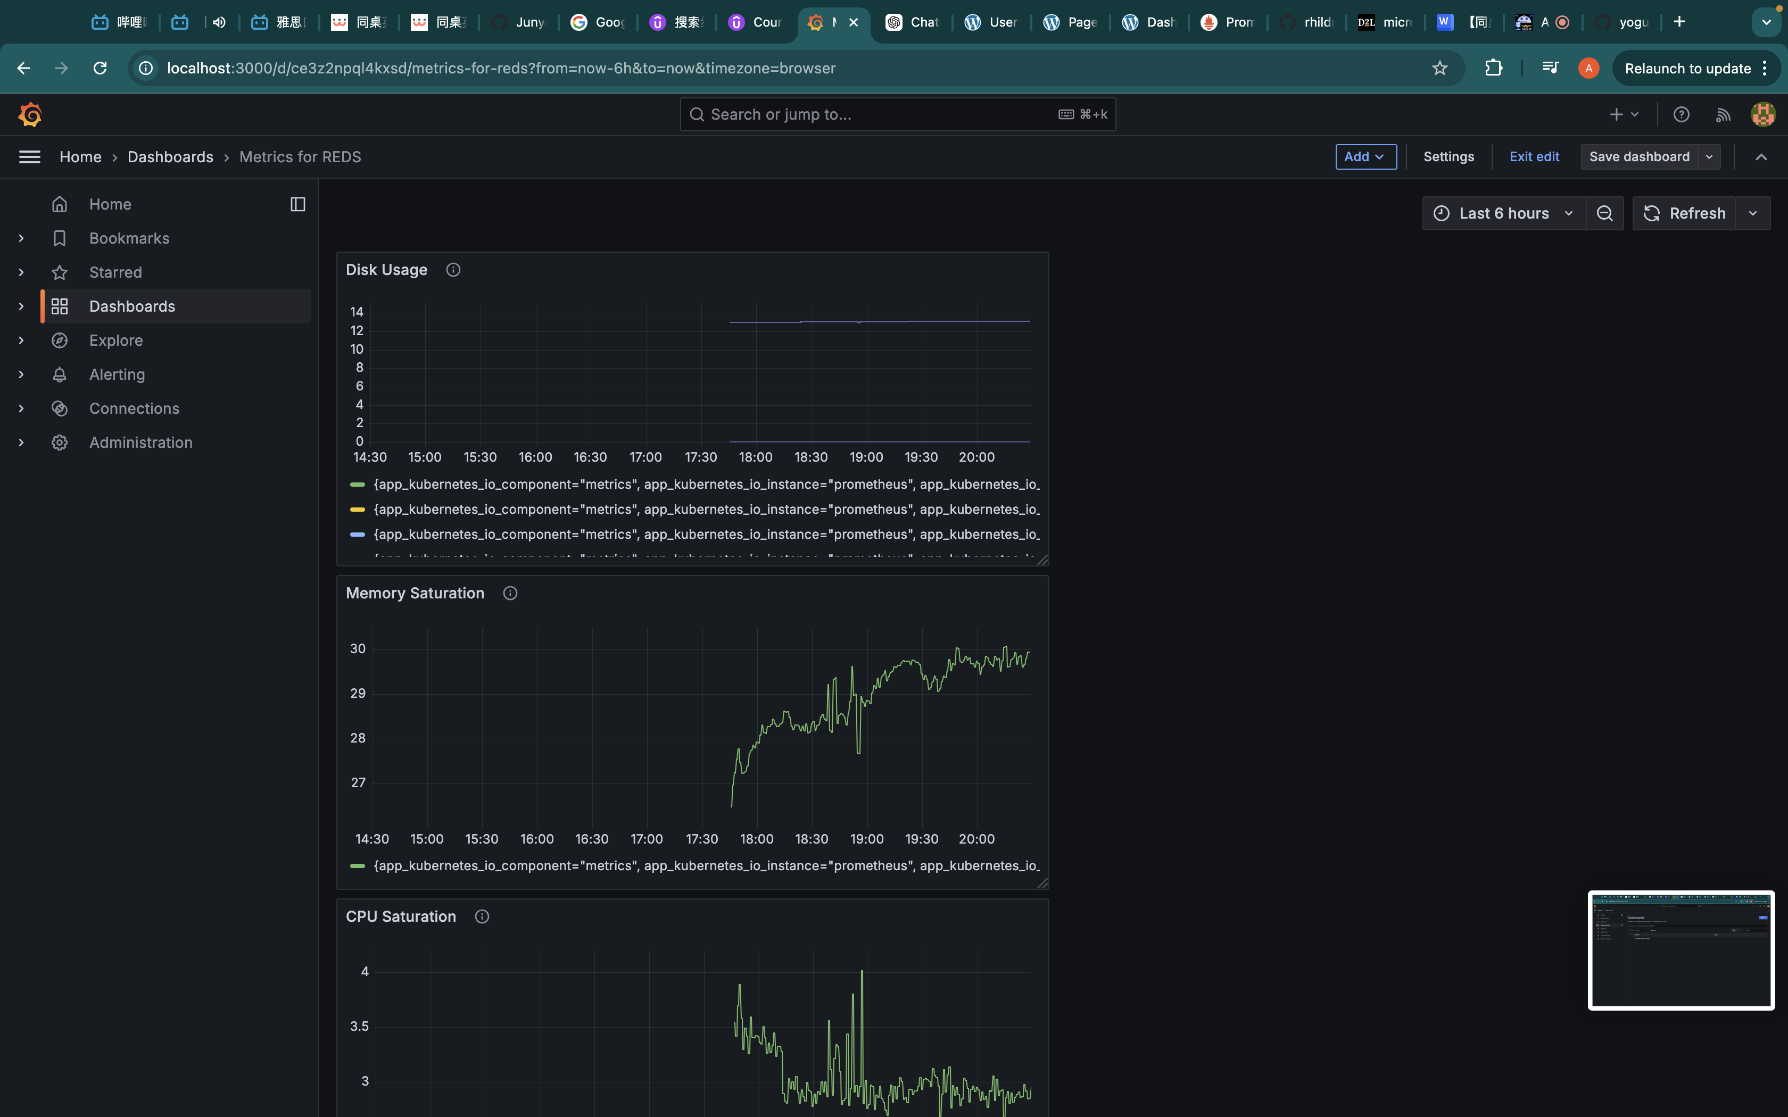

**Trace Requests Through Files**

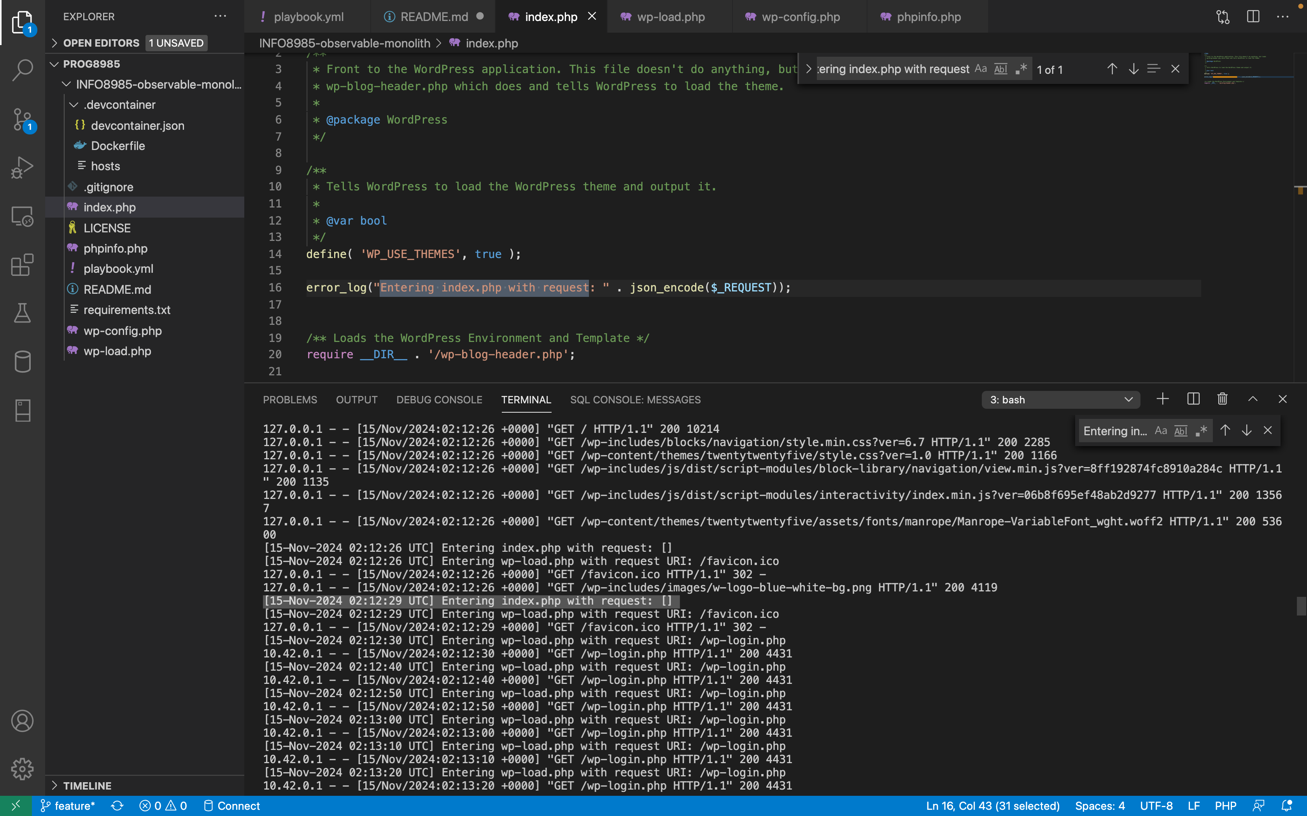Use kubectl logs wordpress-d99967bcc-6cz24 to track the logs  
I set the error log in the index.php, wp-config.php, wp-load.php. In the screenshot, you can see the error log.

**Capture PHP, MariaDB, and Apache Logs**

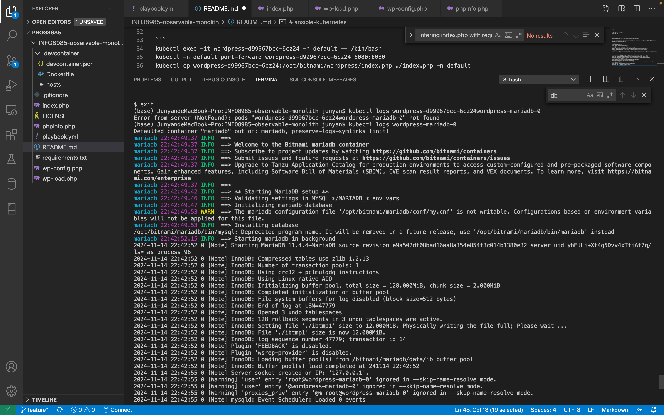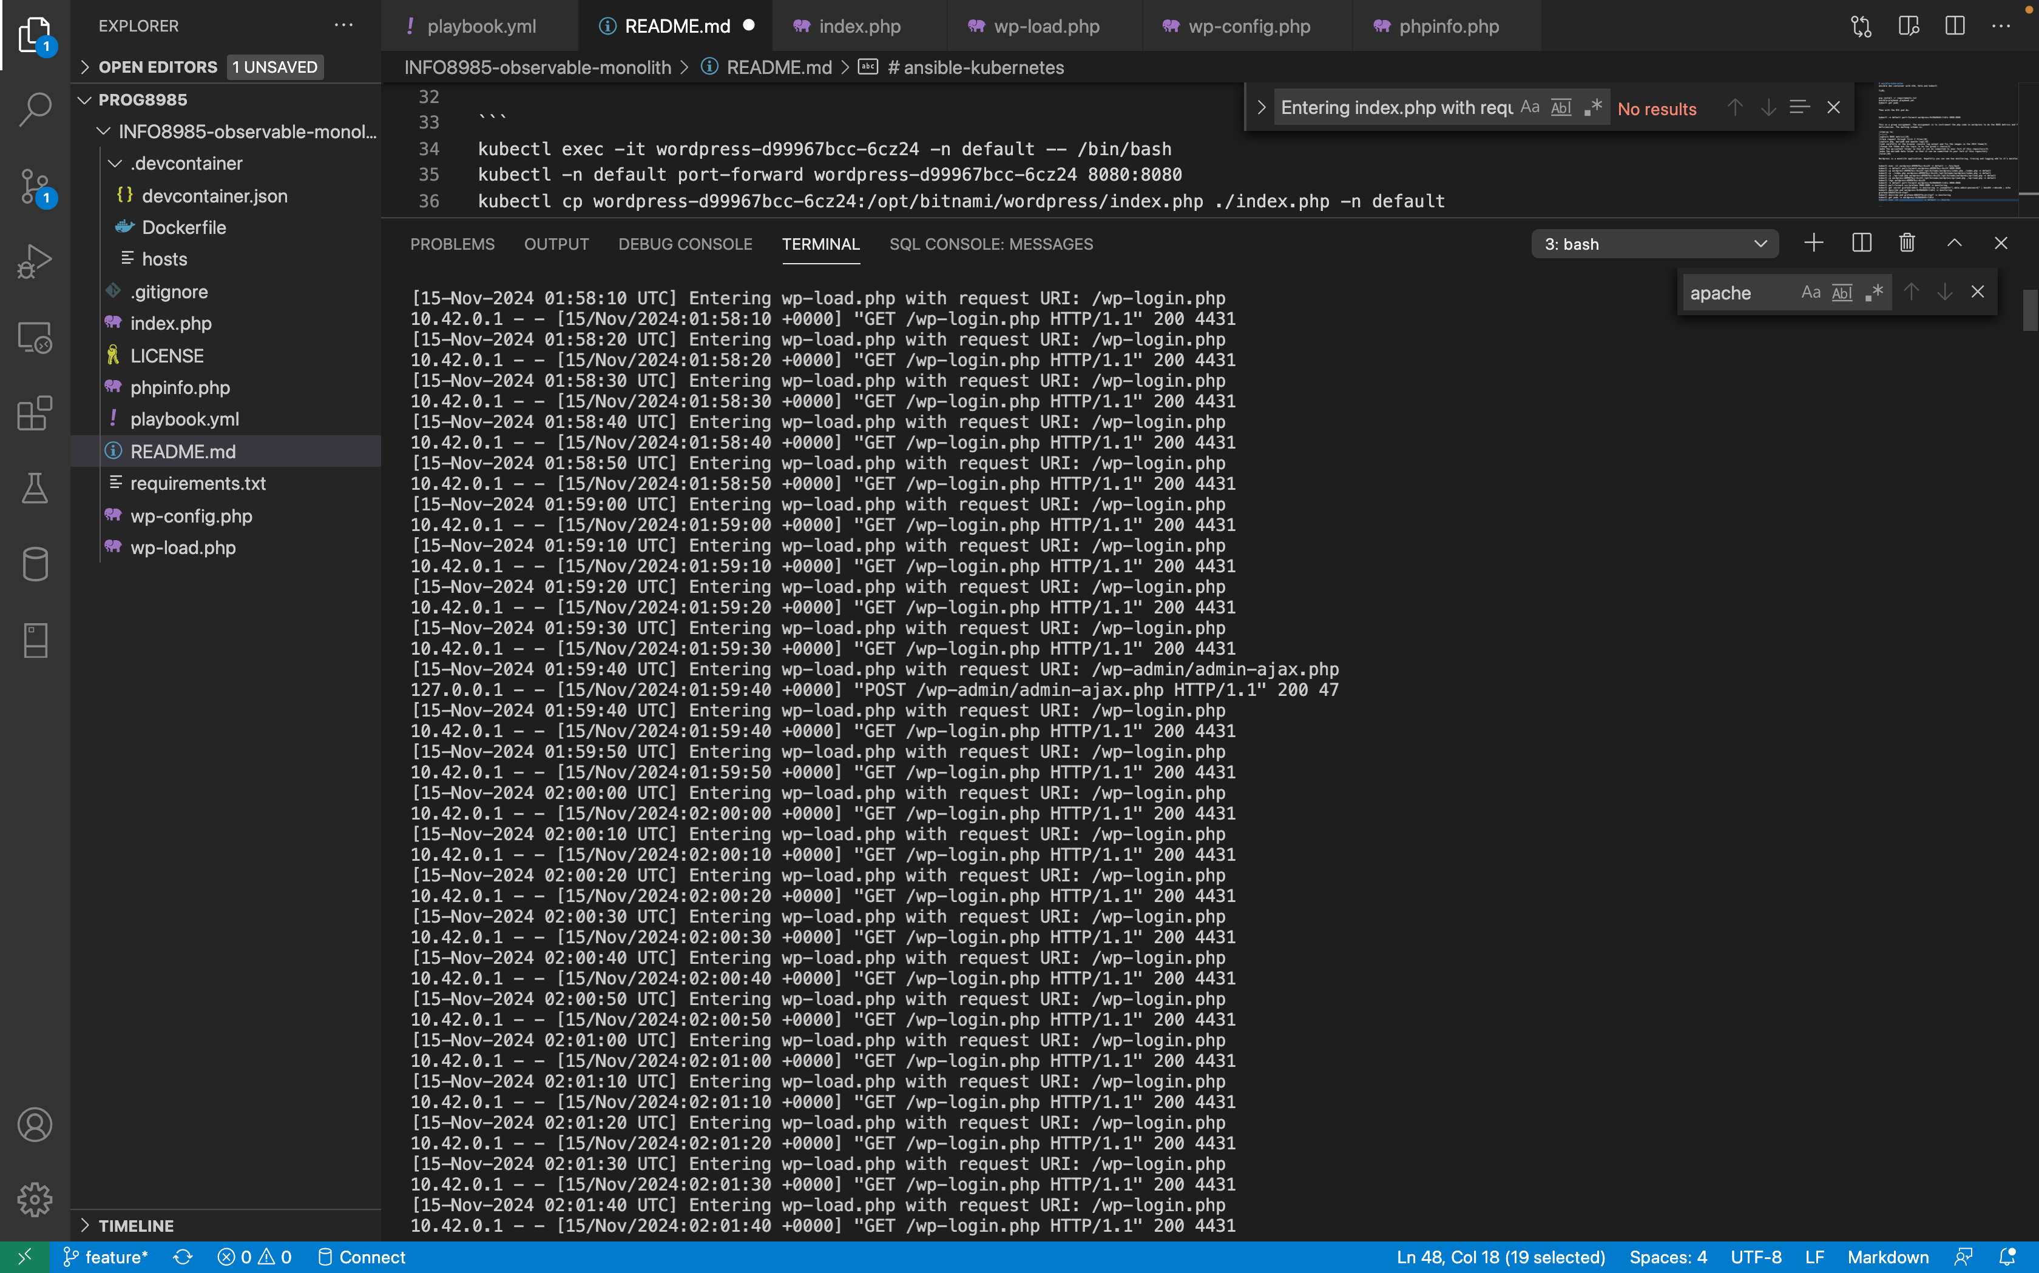

**Fix Console Log Issues**

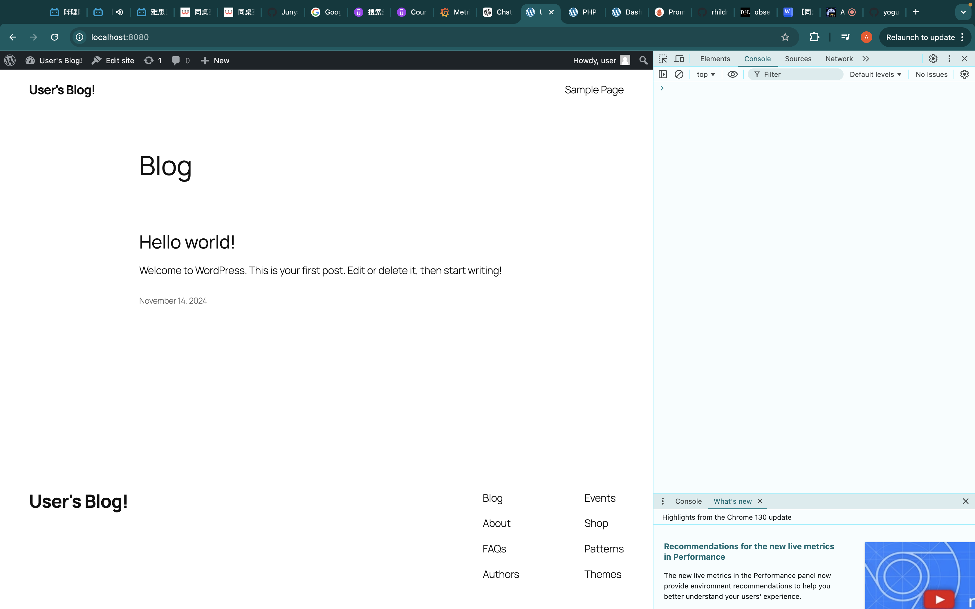

**Change Theme and Topic**

